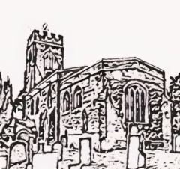

Middleton Parish Council

Notice of Middleton Parish Council Meeting

Wednesday 11th February 2026-Middleton Village Hall, 6.30-8.30pm
Any members of the public or press may attend. Public questions will be taken at the start of the meeting by prior notice to the Clerk. Electors will not be permitted to join in any debate on matters that are to be considered after the meeting starts
AGENDA
1 Public questions:
2. Community Update.
3. Apologies for absence
4. Declarations of personal and prejudice interests
5. Minutes of the previous meeting
6. Matters arising
7. Reports from Councillors and Clerk
8. Planning applications
9. Finance
10 AOB

